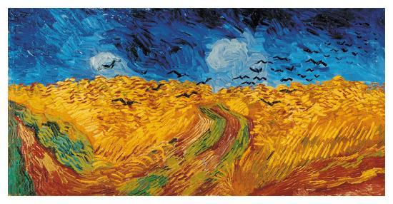Van Gogh Wheatfield with Crows

Vincent Van Gogh was a Dutch painter in the nineteen centuries. His painting “Wheatfield with Crows” last work before his alleged suicide that also occurred in 1890.It is one of Van Gogh’s most famous painting. Wheatfield with Crows is a dramatic landscape painting. This is the image that seeing comes before words. There is a Connection between what we see and what we never see. This painting is unique. The painting has vast fields of Wheat under troubled skies. In the heavy storm the sky, circling ominously low to the ground black birds and empty road receding into the distance, it has another connection with natural as the Berger says. The truth is all things are natural. we do not need to go out of my way to try to express sadness and extreme loneliness. The art historians and connoisseurs of art saw a hint of a clear intention as soon as possible to leave this moral world. This art has stillness and silence. Van Gogh led a sorrowful life up until his death, and his paintings, specifically Wheatfield with Crows, did not fall short in displaying his suffrage. I think the subject matter of the painting and the subtleties that Van Gogh chose to include are relevant to the time when he painted, specifically during his stay at Saint Remy and during about mental illness. This symbolizes the last few months of Van Gogh’s life because this is authentic artwork, not fake as Berger states. The painting to confirm their own verbal authority. The truth is all things are natural. He wanted to show what he considered “healthy and fortifying about the countryside”. Van Gogh used powerful color combinations in this painting: the blue shy contrasts with the yellow orange wheat, while the red of the path is intensified by the green bands of grass. It looks different when we watch it on television or internet.

